BIODIVERSITY

Genetic diversity

Biodiversity (or biological diversity) has to do with variation within living things. It can be described in terms of an ecosystem, at the level of species, or even at the level of individual genes.

Species diversity is the number of different species within an ecosystem.

Genetic diversity is the range of genetic characteristics within a single species. Genetic diversity is important because it produces a variety of phenotypes, some of which may better suit the individual organism to a particular environment than others, giving it an increased chance of survival. This genetic advantage will increase the survival of the species within that particular environment.

Mutation

Mutation can occur in all organisms and is the source of new genetic variation. A change in the genetic code in DNA can lead to a change in the protein that is coded for and produced by that segment of DNA. This can change the organism’s characteristics.

e.g. A change in DNA has led to the production of a protein that changes the colour of the mouse from white to black.

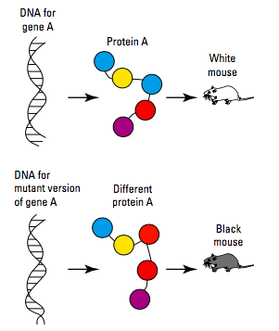

Variation Between Individuals

Variation can occur during meiosis due to crossing over of sections of maternal and paternal chromosomes, and also due to the independent assortment of the chromosomes into the gametes.

The combination of gametes that fuse together during fertilisation provides another source of variation, as does the selection of a particular mate.

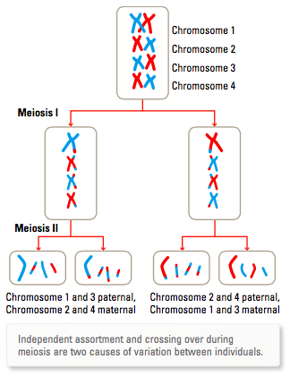

Adaptations

Variations that increase chances of survival may also be thought of as adaptations.

An adaptation is a special feature or characteristic that improves an organism’s chance of survival in its environment. There are different types of adaptations.

• Structural adaptations (e.g. hair to keep warm, hollow bones in birds.)

• Behavioural adaptations (e.g. courtship display to attract a mate, hunting at night, hibernating or aestivating.)

• Physiological adaptations (e.g. ability to produce concentrated urine to conserve water.)

Variation Within Populations

Genetic variation within populations can be referred to the frequency of particular alleles within the population.

While the genotype describes the variation of alleles for a particular trait within an individual, a gene pool describes the alleles for a particular trait within a population.

e.g. Frogs will mate in a particular area, keeping the genetic information for their traits the same with no DNA introduced from the "outside".

If the frogs leave the area, their genetic information leaves as well.

Genetic drift - changes due to chance events - and natural selection - survival of the fittest - can have an impact on allele frequencies and hence variation within populations.

Gene Flow

Movement of individuals between populations provides another possible source of diversity.

Emigration (moving out) may result in the loss of particular alleles.

Immigration (moving in) may result in the addition of new alleles into the population.

e.g. Australia's population has become very multicultural and future generations will show increased mixing of traits from different cultures.

The following diagram summarises the causes of variation.

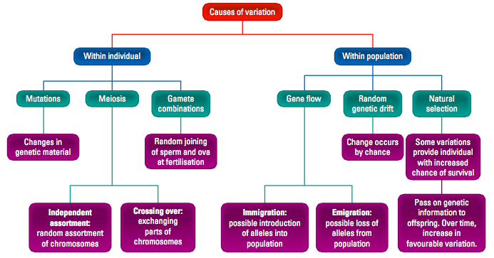

Reduced Biodiversity

The use of reproductive technologies such as artificial selection, artificial insemination, IVF and cloning has the potential to unbalance natural levels of biodiversity. These technologies can be used in horticulture, agriculture and animal breeding to select which particular desired characteristics will be passed on to the next generation.

Artificial Selection

For thousands of years, humans have used selective breeding techniques to breed domestic animals and plants. We have selected which animals will mate together based on their possession of particular features, to increase the chances that their offspring will have features that suit our needs - this is called inbreeding. This type of selective breeding is called artificial selection.

Inbreeding decreases the variation of traits but increases the chances of inherited diseases.

Artificial Insemination

The sperm of a prize-winning racehorse may be used to inseminate many mares, increasing the chance of offspring that also possess the race-winning features of its father.

This leads to a larger contribution of alleles from this horse than would naturally be possible.

It leads to reduced genetic diversity within the populations of horses in which this occurs.

IVF and Embryo Screening

In-vitro fertilisation (IVF) techniques allow the testing and selection of embryos for particular characteristics prior to their implantation. This will have an impact on genetic diversity.

Cloning

Production of a population of genetically identical individuals might make them well suited to a particular environment, but if the environment changes to one that they are not suited, they will die out.

Consequences of Reduced Biodiversity

Reducing variation in genetic diversity can lead to the eradication of populations or entire species.

If the population or species is exposed to an environmental change or threat (e.g. disease, climate change or lack of a particular resource), the reduced variation may mean that there is less chance that some of the species will survive to reproduce.

